Taipei Medical University Faculty Teaching Professional Certification Application Form

Application Date: Year Month Day
Name |  |  | Department/Program
Job Title |  |  | Employment Start Date |  | (For new faculty only)  Year Month
Application Content | (Foreign faculty are exempt from this application)  □Basic - Complete 8 hours of mandatory and 8 hours of elective courses
Application Content | □Advanced (Social Practice Group) - Complete 8 hours of mandatory courses and 6 hours of elective courses, and offer one course related to guided learning–oriented teaching or USR.
Application Content | □Advanced (Digital Learning Group) - Complete 8 hours of mandatory courses and 6 hours of elective courses, and offer one distance-learning course with at least 9 weeks of instruction, or integrate VR/AR into two courses (minimum 2 hours per course).
Application Content | □Advanced (Professional Core Competency Group) - Complete 8 hours of required courses and 6 hours of elective courses; offer one core competency course (or a 2-credit course), or integrate simulation teaching into one course (at least 4 hours in total).
Application Content | □Advanced (AI Teaching Group) - Complete 8 hours of required courses and 6 hours of elective courses; and offer one AI-enhanced professional application course (or a 2-credit course) (AI+X), or substantially integrate AI-assisted teaching strategies into a professional course for at least 9 weeks.
Application Content | □Advanced (EMI Teaching Group) - Complete 8 hours of mandatory courses and 6 hours of elective courses; Offer EMI professional courses totaling at least 16 hours, participate in classroom observation, join EMI teaching community at least five times, and provide a 3–5 minute course video.
Application Content | □Advanced (Innovative Teaching Group) - Complete 8 hours of mandatory courses and 6 hours of elective courses; and offer 1 course on innovation and entrepreneurship, or incorporate innovation and entrepreneurship teaching into course (1 course), or guide 2 student teams in competitions
Application Content | □Senior - Serve as a lecturer in teacher-related workshops or seminars for 16 hours; and be the principal investigator of a government teaching/education-related project or be the primary instructor of a course certified by the Ministry of Education’s digital curriculum program.
Application Content | Attach Relevant Supporting Documents (Please verify before submitting): | □Course records (Excel from Continuing Education System)  □Course syllabi: Attach course syllabi or other documents (mark the number of weeks for introduction to facilitate identification)  □Teaching practice report (for Digital Learning Group, Professional Core Competency Group, AI Teaching Group, Innovative Teaching Group)  □Proof of workshop/seminar teaching: Served as a lecturer for 16 hours in workshops or seminars: Attach agenda or a certificate specifying the hours  □Project documentation: Principal investigator of a teaching/education-related project: Attach supporting documents  □Other (Please explain):
Remarks:
All requirements must be completed within two academic years before the application year.
Review Process  Applications will be reviewed by the responsible administrative unit. |  |  |  | □Meets requirements  □Does not meet requirements
FC-01-C-20220125

Application Guidelines for Advanced EMI Group Teaching Professional Certification

I. Eligibility Criteria
1. Courses Taken
Applicants must complete 8 hours of mandatory courses and 6 hours of elective courses from the EMI Teaching Group offered.
2. Participation in the University EMI Teacher Community
Applicants must participate in EMI teaching community activities at least five times.
- Any activity explicitly labeled “Community” qualifies as a community activity
(e.g., 114認證-EMI(必)-(Community)).
- If you are unsure whether an activity qualifies as a community event, please contact
Mr. Huang at the Bilingual Center (tmujimmy0909@tmu.edu.tw).
3. Offering Full-English Professional (Non-Language) Courses
Applicants must fulfill all of the following conditions:
- Study List of 8 Hours Mandatory Courses and 6 Hours Elective Courses (Please download from the system)
- The total teaching hours must be at least 16 hours.
- Applicants must agree to participate in classroom observations.
- Applicants must provide a 3–5 minute course introduction video for at least one course.

II. Required Documents
1. Course Syllabus
Applicants must attach the course syllabus, which must clearly indicate the following:
- “EMI Teaching”: Yes
- “Teaching Materials Including Original Texts”: Entirely in English
- For co-taught courses, please indicate:
  - the applicant’s teaching weeks and hours, and
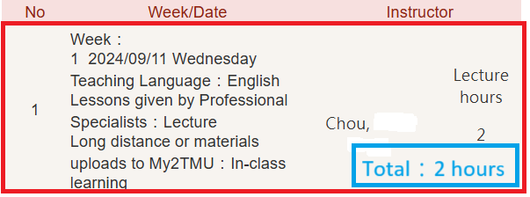
  - the total teaching hours of the course.
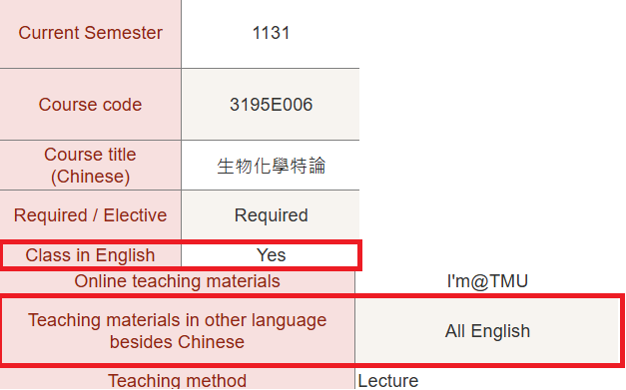

2. Classroom Observation Certificate
During the offering of the full-English professional (non-language) course, applicants must submit a request to the Bilingual Education Promotion Center to arrange a classroom observation.
After the observation, applicants must apply for and obtain a certificate of participation.
3. Course Video Introduction
- Record a 3–5 minute introduction video for at least one full-English professional (non-language) course taught by the applicant.
- Upload the video to YouTube and provide the URL link.
- Please provide the URL here :

